ELEC 3EY4 – Lab 6

1 Coordinate Frame Assignment in MacAEV

Activity 1
Shown below are the calculations required for computing the ROS static transformations and the link used as a tool for the quaternion conversions: Conversion between Quaternions and Euler Angles
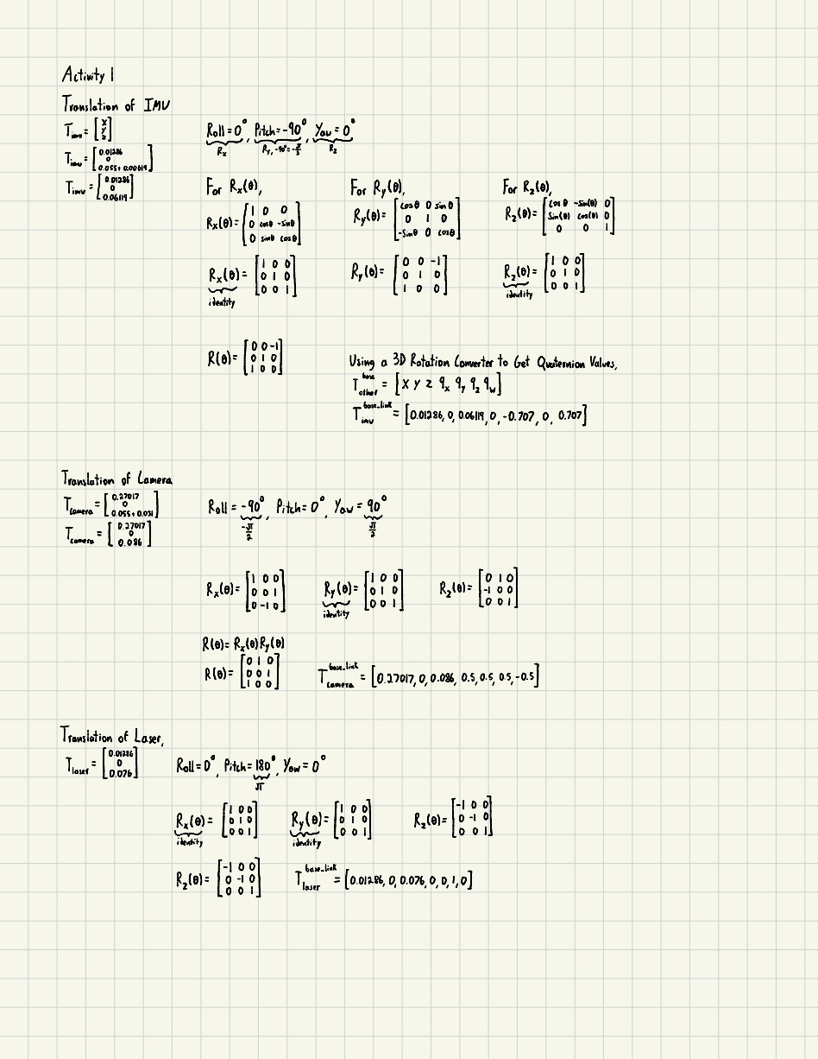
The parameters in the file have been updated as shown below:
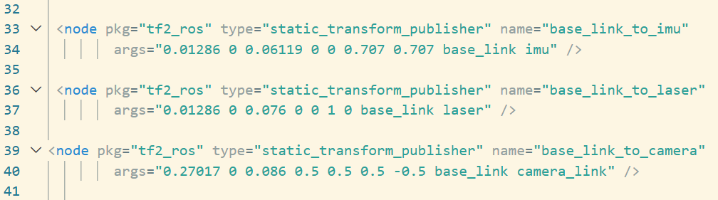
The file ‘experiment.launch’ has been updated accordingly and attached in the submission.

2 BNO055 Inertial Measurement Unit

Activity 2
Quaternions help to solve the issue with gimbal lock (with the use of a rotation matrix and Euler angles). Gimbal lock happens when two of the axes of rotation (with the use of euler angles) get lined up, we lose a degree of freedom. It can also cause difficulties with interpolating two different orientations. Instead of using three seperate sequences of rotations around three axes, we can use quaternions to represent all three orientations in one, around a single axis of rotation.
If we think about how complex numbers can give us the coordinates of 2D rotations (multiplying cos(theta) + sin(theta) i, where i^2 = -1), the quaternion rotation is similar. We have one axis of rotation that's defined by a unit vector, normalized that the sum of those components is equal to 1 (with definition i,j,k). We then use a rotation angle θ, and divide that angle by 2 to construct the quaternion by taking (cos(θ/2) + sin(θ/2)i), and multiplying that by a vector representing the single axis of rotation.
In terms of rotation around a frame, the quaternion describes the orientation of an objects local reference frame, in relation to the global reference frame (in our case that global frame is odom). The normalized vector mentioned earlier will be multiplied by sin (θ/2) to give us the corresponding vector of the quaternion (qx, qy, qz), and the scalar portion (qw) is equal to cos(θ/2) will give us the amount of rotation around the axis.

Activity 3
Completed just as listed in the lab manual.

Activity 4
The corresponding .bag file is included with the report submission.

3 Localisation with Wheel Odometry and IMU

Activity 5
The corresponding ‘experiment.cpp’ file is included with the report submission.

Activity 6
- Discuss potential sources of errors in wheel-based odometry computations that may cause a drift in the computed pose of the vehicle.
- What do you expect the impact of using IMU measurement for yaw angle to be on the localization errors?
- Use the rosbag utility to record the vehicle pose during the experiment and include this file as part of your lab report submission
We can see in our rviz window that the base link frame does not align back to its original frame, which is due to a multitude reasons. This will become a small issue as later if we want the vehicle to return to its starting position, which is not possible if the frames are aligned from the get-go.
Some reasons for the “drift” we see can be due to wheel slip, loss of traction for the bot, and rounding errors when calculating the transformation matrices earlier in activity 1. One factor that can also affect the positioning of the bot is the limited resolution of the encoders, missing measurements at certain time steps which will also throw off the bots position over a period.
The imu serves the purpose of establishing the yaw angle through finding the angular velocity and acceleration via an accelerometer with 3 degrees of freedom, a gyroscope (angular velocity, 3 degrees of freedom) and magnetometer (3 degrees of freedom). As the imu updates repeatedly, our orientation data will be updated consistently, which will combat the drift we see due to the reasons seen above. By incorporating the imu, our yaw measurement accuracy increases therefore minimizing the localization errors seen in our rviz.

4 Mapping using LiDAR and Wheel Odometry Data

Activity 7
The corresponding ‘occupancygridmap.py’ file is included with the report submission.

Activity 8
The corresponding .bag file is included with the report. Below is the resulting occupancy grid map as displayed in rviz.
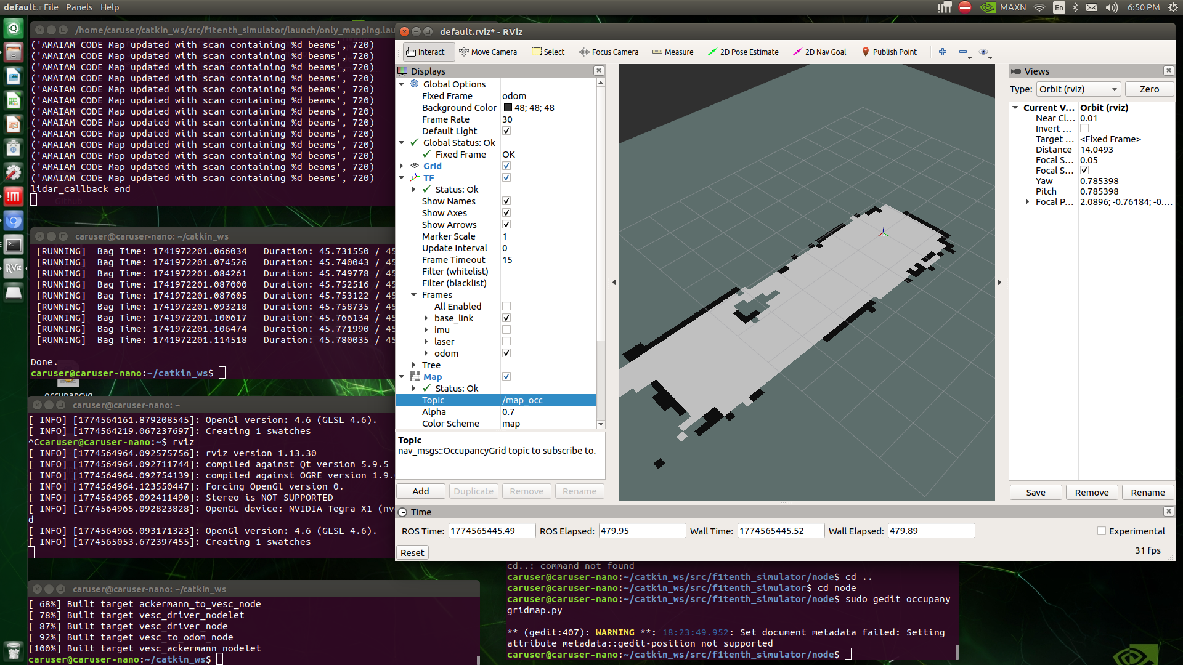

Activity 9
- Upload the ROS bag file onto the Avenue along with your report
- Comment on your observations and particularly on the sources of mapping errors.
- What happens if you have moving obstacles in the environment?
- Note that this technically violates the assumption of a static environment under which the Occupancy Grid Mapping algorithm was developed

Activity 10
- Write a closing statement summarizing what you have accomplished in this lab.
Throughout this lab, we have utilized quaternion vectors to express the required rotations and translations needed to align the required vehicle sensors.
- Comment on the limitations of the localization and mapping algorithms you have developed.
- Suggest ways in which you can potentially address some of these limitations

